Perimeter and area
In general, perimeter and area of simple and compound shapes is covered in Mathematics A textbooks adequately.
The Practical activities section of this topic has surveying exercises that culminate in the calculation of perimeter and area of the scale diagrams constructed from the given information.
How would you find the perimeter of an irregular curved shape?
- Use a piece of string.
- Use a grid and approximate by counting. Would the size of grid square matter?
- What method do you think a surveyor would use? Investigate.
How would you find the area of an irregular curved shape?
- Use a grid and approximate by counting.
- Use calculas and calculate the area under the curve. How would you derive the function to integrate? Could you derive a function?
- Break it up into smaller or component areas - then what?
- Divide it into strips and use the area of rectangles to approximate the area. Lower sum → Upper sum → Mid-point sum. Which is the best estimate? How does increasing the number of strips effect the final result?
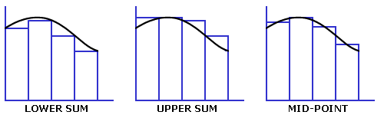
Area = Σ areas of the rectangles
- Use the trapezoidal rule for area after dividing the shape into a suitable number of strips as shown in the diagram below. What effect does increasing the number of strips have on the final result?
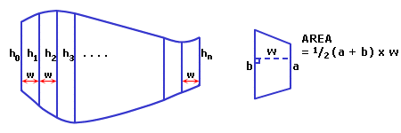
Area = w × (h₀/2 + h₁ + h₂ + h₃ +... + h_{n}/2)
Examine how this rule is derived from the rule for the area of a trapezium. Why is the height halved at each end but not in the middle? Do the strips have to be of equal width? Is the number of strips important?
- Try Simpson's rule, which assumes the curve approximates a number of parabolas. Divide the shape into a number of even strips and work with them two at a time.
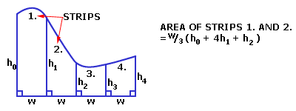
How would you calculate the total area of the curved shape? Consider how this rule is derived. Does increasing the number of strips affect the final? result? Is the placement of the divisions of any importance?

http://education.qld.gov.au/curriculum/area/maths/compass/html/surveying/suact1.html

Worksheet:
Assume all measurements are in metres. Choose an appropriate scale.
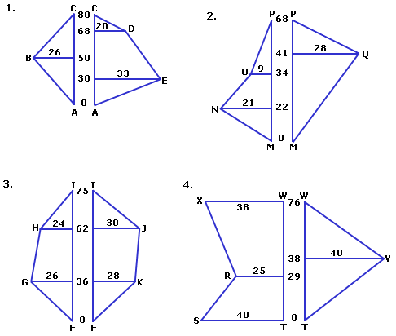

Answers:
- P = 199m, A = 266m2
- P = 178m, A = 1516m2
- P = 202m, A = 2727m2
- P = 269m, A = 3943m2

Surveying activity 2: Triangulation

Aim:
To practice the method of surveying using triangulation. To find perimeters and areas of the land surveyed.

What you need:
- Worksheet
- Paper, ruler, pencil and eraser
- Protractor
- Calculator

Instructions for students:
The diagrams on the worksheet represent notes taken by a surveyor in the field. The surveyor has established a baseline XY of known length. W is the position to be determined and this has been accomplished by taking bearings to W from X, and to W from Y. A rough sketch and the measurement details are recorded in the surveyor's notebook.
Question: What equipment do you think the surveyor has used for this survey?
Your job is to produce an accurate scale drawing of the area surveyed. You must select an appropriate scale for the size of your page. Consider the angles carefully. You may need to think about the angles involved as each diagram has a north line. For surveying the relationship to north is important. Take care with question 4. It will give you a four-sided figure and is an example of a multiple triangulation (in practice surveyors may use many triangles to cover an area).
When each drawing is complete find the perimeter (by measuring) and the area (by Heron's Formula) of the land. Question 4 will require you to think about the area calculation. A different method may be used. Trigonometry may be required. Answer to the nearest metre.
Question: What is Heron's Formula for the area of a triangle? Write it down and remember it.

Notes for teachers:
The following worksheet has four diagrams of notes taken in survey by triangulation. The answers are given at the bottom of the page. Encourage students to discuss the sources of error and decide whether the errors are significant or not. What is an acceptable difference to the given answer?
This technique of surveying can be practiced in the school grounds. Students should think about the equipment needed to perform the survey. Hand held compasses are sufficient but you may find the Manual Arts department has a dumpy level, or two, and these are the better option. Plane table equipment and techniques can also be used. Remember that it is good practice to double check all measurements by an alternative means. For example, back-bearing to check bearings, two independent measures of distance, two angles to position a point and three to check its validity.

Worksheet:
Assume all measurements are in metres. Choose an appropriate scale. Remember to work in relationship to the indicated north line.
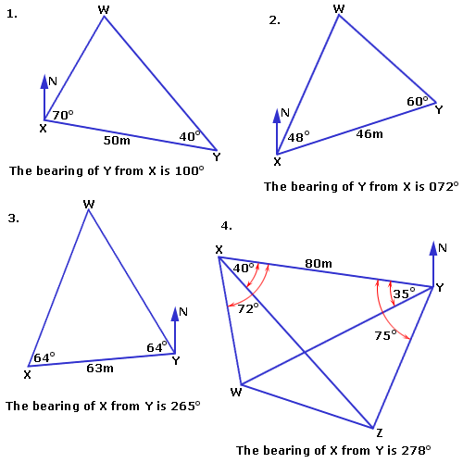

Answers:
- P = 135m, A = 820m²
- P = 124m, A = 718m²
- P = 207m, A = 2039m²
- P = 235m, A = 3262m²

Surveying activity 3: Radiation

Aim:
To practice the surveying technique of radiation. To find perimeter and area.

What you need:
- Worksheet
- Paper, ruler, pencil and eraser
- Protractor
- Calculator

Instructions for students:
The diagrams on the worksheet represent notes taken by a surveyor in the field. The surveyor has first drawn a north line to which all bearings and distances are referenced. The north line does not form a part of the land area being surveyed. This would only be the case if there were a distance indicated on it.
Question: What equipment do you think the surveyor has used for this survey?
Your job is to produce an accurate scale drawing of the land that has been surveyed using the information from the notes. You must select an appropriate scale for the size of your page and take care with the accuracy of your measurements.
When your drawing is complete find the perimeter by measuring the lengths of the sides carefully. Also find the area of the last scale drawing using Heron's formula. Answer to the nearest metre.
Question: What is Heron's Formula for the area of a triangle? Write it down and remember it.

Notes for teachers:
The following worksheet has four diagrams of surveys by the method of radiation. The answers are given at the bottom of the page. Students should discuss the source of errors and consider the size of an error as significant, or otherwise.
This technique of surveying can be used to find the perimeter and perhaps the area of a selected part of the school grounds. Students should think about the equipment needed to carry out the practical work of the survey and remember that it is good practice to double check all measurements by an alternative means. For example, back-bearings to check bearings, two independent measures of distance, two angles to position a point and three to check its validity. Investigate whether there are dumpy levels available in the school, perhaps through the Manual Arts department. Hand compasses are sufficient but to experience using a dumpy level would be better.

Worksheet
Assume all distance measurements are in metres an angle measurements are in degrees. Choose an appropriate scale. Label the diagrams clearly and show all lengths.
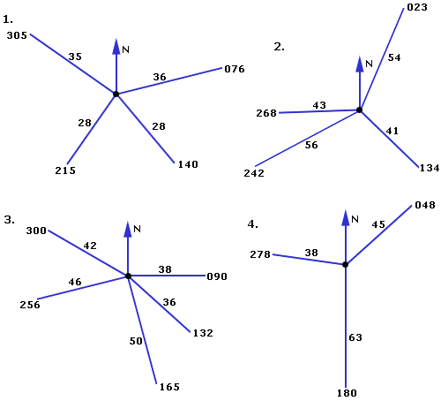

Answers:
- P = 178m
- P = 266m
- P = 231m
- P = 253m, A = 2919m2

Surveying activity 5: How far?

Aim:
To use the principles of geometry and trigonometry to determine the distance between two locations, in particular places which are inaccessible to manual measurement.

What you need:
- Measuring tape or trundle wheel
- Compass or dumpy level
- Notebook and pen to record data
- Instructions for students:
Method (1): Imagine an object located on the far side of a river. You want to know how far it is away. This can be done using the properties of an isosceles triangle. Fix a position at 90° to the object on the near side of the river. Walk at 90° to this line along the bank until the bearing of the object is 45°. Measure the distance walked. This is equal to the distance across the river to the object. See diagram A below.
Method (2): Use trigonometry to calculate the distance across the river. Fix your position at 90° to the object on the near side of the river. Walk at 90° to this line along the bank for a known distance and take a bearing to the object. The tangent ratio can then be used to calculate the distance across the river. See diagram B below.
Method (3): Take any two bearings to the object from a base-line on the near side of the river. Measure the distance between the positions from which the bearings were taken. Produce an accurate scale drawing from the data collected. Construct and measure the perpendicular distance to the object on the scale drawing.
Method (4): Any other legitimate procedure. Students may find any number of ways to calculate the distance - great! The important thing is for the solution to be supported by diagrams and calculations which justify the method used.
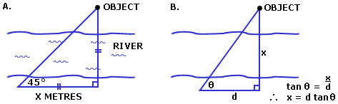
This type of practical work can be done in the school grounds by selecting an object that lies beyond some sort of barrier. For example, on the other side of a fence, road, creek or pathway. An important rule is that no one crosses the barrier.
Students can be asked to use at least two different methods to find the distance and to justify the work they have done with diagrams and calculations. Whatever method is used the answers obtained should agree.

Item 3. Doubling the angle
'Doubling the angle on the bow' is used in marine navigation but can be applied equally well to land navigation problems. A land problem could involve sightings taken to a hill, or water tower, or similar.
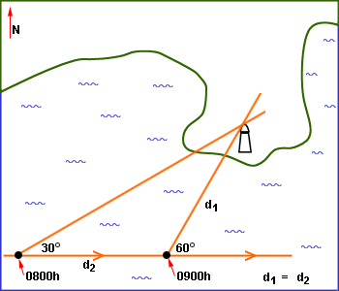
An explanation and more information can be found in the topic Coastal navigation, Chart work and fixing position.
A general description of the procedure is:
Following a given course bearing (e.g. 090°) at a given speed (e.g. 10 knots; 5 km/h ), a feature (e.g. lighthouse; water tower) is noted to be at 30° at a particular time (e.g. 0800h) and at 60°, double the angle, at a later time (e.g. 0900h).
How far from the feature are you at 0900h?
The solution to this problem arises from the isosceles triangle formed by the distance travelled in the hour (d₂) being equal to the distance away (d₁) from the feature at the later recorded time. This requires no chart work but simply the calculation of the distance travelled.
Many investigations can arise from this:
- Prove that the distance travelled is equal to the distance off.
(Maths B)
- Fix the positions at the two given times on a chart or map by accurate construction from the given information. The information required is specific to a particular chart or map with a clearly identified feature. The construction is not straightforward as the observed feature becomes the starting point and correct bearings from the feature must be obtained to give the position lines. Distance is then plotted on the later position line and finally the line of the course bearing can be drawn using the known course bearing and the calculated distance. The construction actually involves working backwards with the initial position (in the question) being the final position plotted (in the drawing).
- A course of due north makes the construction quite easy, 090° leads to some thought about the angles and a course of 237° makes the problem much harder!
- 10 knots for 1 hour is straightforward, but 15 knots for 40 minutes becomes a difficult calculation. By varying the course bearing, time taken between sightings and speed of travel, the problem can be anything from straightforward to relatively difficult.
(Maths A/B - Isosceles triangle; Axioms of deductive geometry - lines, angles, parallel lines; speed/distance/time calculations; geometric construction)
- Find the distance from the initial position to the point at which the traveller will be abeam (at 90° to) the feature.
(Maths A/B - Trigonomic ratios to find the additional distance).
- Show that the 'distance abeam' is always less than the 'distance off', if the initial bearing taken is less than 45°.
(Maths A - by example; Maths B - theoretical).
- Investigate situations when the initial bearing taken is 45° (four-point fix) and when it is greater than 45°. A four-point fix is included in the topic Coastal navigation, Chart work and fixing position.
- Find the distance from the observed feature when the initial bearing was taken.

Assessment
The items that follow are suggestions and contributions from a number of sources including schools. I have been sent samples and have collected ideas to consider and include as appropriate assessment tasks. More questions are found in the topic Taking geometry seriously and throughout the main topics in the activities and exercise sections.
- Deviation - trigonometric functions  - Tables, graphs, functions  - Area - irregular shapes  - Surveyors' trick  - Golden ratio | - Tables, graphs, functions  - Orienteering problem  - Orienteering assignment ideas  - Surveying assignment ideas  - Area - Heron's formula

Item 1. Deviation - trigonometric functions
A perfect example of a trigonometric function occurring as a natural phenomena is deviation of the compass which is the deflection of the compass needle caused by the magnetic field present in any craft (marine or air) due to its construction, and equipment carried. More information on this can be found in the topic Compasses and bearings under Deviation, declination and variation and Coastal navigation, Swinging the compass.
Deviation is the difference between the compass bearing and the known magnetic bearing. It is specific to a particular craft and after the compass has been 'swung' through the eight cardinal (N,S,E & W) and inter-cardinal (NE,SE,SW & SE) compass points, the craft is issued with a deviation card such as the one given below. From the card a pattern is not obvious but when the points are plotted and joined by a smooth curve, a lovely trigonometric function is obtained.
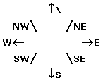 | ⇑ MN

Craft's head | Deviation
N 000° | 2°W
NE 045° | 4°W
E 090° | 3°W
SE 135° | 1°W
S 180° | 2°E
SW 225° | 4°E
W 270° | 3°E
NW 315° | 0°
N 360° | 2°W
--- | ---
Investigations might include:
- Plotting the curve and determining an appropriate equation for it.
- Discussion of 'east' and 'west' for labelling the deviation axis. Which should be regarded as the negative quantity? Does it matter?
- Use of graphics calculators - tables and lists; graphing; curve fitting - regression.
- Estimating/predicting deviation for the craft on headings such as 060°, 140° or 295°.
- Finding the compass course (actual bearing the craft must steer):
Compass course = True bearing ± Variation ± Deviation
- Is there a relationship involving the deviation at points in opposition to each other? Look for patterns and properties.

Item 2. Tables, graphs, functions
A range finder is sometimes used by golfers to estimate the distance to the flag on the green. A simple range finder is inexpensive (and not particularly accurate). It is a little black box about 10cm square by about 1.5cm deep. There is a small window on one side to look through and a screen is seen that looks similar to the diagram below. By lining up the flag between the two lines an approximate distance can be obtained. The diagram here is approximate - it is up to the students to derive/deduce a correct curve themselves.
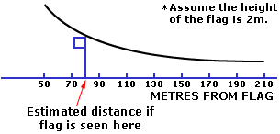
Investigations might include:
- Derivation of the curve and its equation.
- Identify the type of function.
- Graphics calculators - tables and lists; graphing; curve fitting - regression
- Evaluation of accuracy, or lack of, considering such things as the precision required by the average golfer, the professional golfer, visibility of flags and consistent height of flags.
- Research other types of range finders available.

Item 3. Area - irregular shapes
Finding the area of an irregular curved shape (piece of land). The Surveying sub-topic Perimeter and area investigates various methods of calculating area by dividing an irregular curved shape into strips. Integration is another solution - for areas bounded by curves for which an equation can be found.
Here is another method to investigate using an instrument called a planimeter. The planimeter applies mechanical integration to figures of any shape and are considered to be very accurate. It has a block and pin to fix the instrument securely to the paper. There is a pole arm from the block to an integrating unit and a tracing arm from the integrating unit to a tracing point. See the diagrams below. If the instrument is securely fixed and the tracing arm is moved around the outline of the figure, then the integrating disc will register an amount proportional to the area of the figure.
Using a planimeter
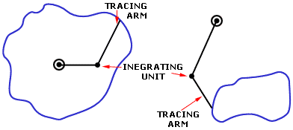
Example: What is the area of a piece of land on a plan that is measured as 1613mm² by a fixed-arm planimeter if the scale of the plan is 1:2500?
On this scale, 1 mm² represents 2500 mm².
Hence 1613 mm² | = 1613 × 2500 × 2500 mm²  ^{= 1.008 hectare}
Investigations might include:
- Areas of irregular shapes by a variety of methods.
- Research in more detail planimeters and obtain the use of a planimeter.
- Compare the accuracy and efficiency of the various methods for finding area.
- Application of the procedures to an area in the school grounds, or local community, or cadastral maps from within your Shire.

Item 4. Surveyors' trick
Surveyors check and double-check all measurements to be recorded. Bearings and reverse bearings are often checked by a simple addition of the hundreds and tens columns as shown in the topic of Surveying under 'Did you know?' in Techniques.
An interesting investigation arising from this simple check is Modulo Arithmetic.

Item 5. Golden ratio
Investigate the properties and patterns of the Golden Ratio (Golden Number):
(√5 + 1)
2
- History and use of the ratio (1 : (√5 + 1)/2) in nature; and in architecture, in particular.
- Find examples for the above.
- Relationship of the number to Fibonacci numbers.
- Demonstrate how the how Fibonacci series produces increasingly accurate approximations to the number.
- Construct (not just draw) accurately a rectangle of 'golden proportions'.

Item 6. Tables, graphs, functions
The following table gives the distance of the sea horizon for various heights of eye, both in metres and in feet. It enables quick judgements to be made of approximate distances off the coast. The distances are those where waves could just be seen breaking on the shore. If an observer, with a height of eye of 3 metres could not see waves breaking on the shore, then from the table his distance off the shore must be more than 3.6 n.miles.
  Eye height  (metres) | Distance off  (n.miles)
  1 | 2.08
  2 | 2.94
  3 | 3.60
  4 | 4.16
  5 | 4.65
  6 | 5.09
  7 | 5.50
  8 | 5.88
  9 | 6.24
  10 | 6.58
  Eye height  (feet) | Distance off  (n.miles)
  4 | 2.30
  6 | 2.82
  8 | 3.25
  10 | 3.64
  12 | 3.98
  14 | 4.30
  16 | 4.60
  18 | 4.88
  20 | 5.14
  22 | 5.39
Investigations might include:
- Plot the curve and looking for a relationship.
- Derive/deduce an equation for the curve.
- Identifying the type of function.
- Graphics calculators - tables and lists; graphing; curve fitting - regression.
- Predict the height of eye for a distance of 10 n.miles off the shoreline. Is there a limit to the height of eye? Is there a limit to distance off the shore?
- Create a problem situation where distance off the shore is required for safe navigation (with reference to a particular chart). This could be part of an exercise on chart work - plotting a course involving a number of fixes, as well as the above.

Item 7. Orienteering problem
Two orienteering competitors Peter and Ada arrived at control A together but left in opposite directions in their search for control B. Peter headed due south for 150 metres before heading due east, where he found control B after running a further 600 metres. Ada meanwhile started out in a northerly direction before changing to a bearing which took her straight to B. Interestingly both competitors had covered the same distance in their routes from A to B. How far north did Ada run before changing direction.

Item 8. Orienteering assignment ideas
- Students, working in small groups, set out an orienteering course of five or six stations in the school grounds, or other suitable area available to you, and produce a map of the area and their course, to scale and showing the main features of the area. They also provide a set of instructions giving direction and distance between the stations, and the features identifying each station on the course. Another group then follows the course. An evaluation sheet is completed and a report written on the design and accuracy of the course.
- Queensland School Orienteering will work in conjunction with schools and are keen for schools to use courses on maps that they have produced. It is possible to organise an excursion in many local areas with experienced orienteers, genuine courses and maps, cards and equipment for just $4 per student ($2 per student if you don't want maps). The students experience the full range of activities that make up an orienteering run. A report to follow the activity could include the production of their own map of the course, evaluation of the use of compass, pacing and other aids to complete the course, importance of observation of features and reading the map correctly and any problems experienced along the way. Times for completion of the course are recorded and this could form part of the marks awarded for the assignment. This is a good opportunity for students to be involved in a real life situation.

Item 9. Surveying assignment ideas
Surveying assignment ideas with use of surveying equipment such as a dumpy level, plane table and alidade, compasses and tapes.
- Set up a traverse (Pegs A - ?) in a suitable area. A sample diagram is shown below.
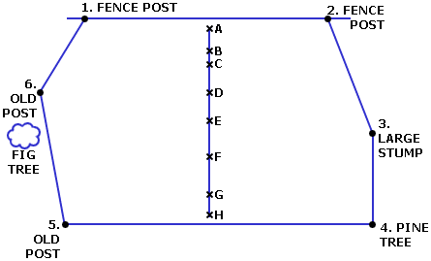
Students, working in small groups, measure the distances accurately between the station pegs and record the information in a table (see Table 1. below). Two pegs are nominated (e.g. B and F) as the stations from which bearings will be taken (see Table 2. below) and the map eventually drawn using the technique of triangulation. The final product of the assignment to be a plan of the area (scale 1:2000) and a traverse profile (scale 1:1000) with all relevant and required detail shown. Consider finding the perimeter and/or area of the surveyed land as an additional task.
Table 1.
 | Station | A to B | B to C | C to D | D to...?
Field work | Distance (metres)
Field work | Angles (±)
Field work | Sketch (slope)
Calculations | Horozontal (metres)*
Calculations | Vertical (±) (metres)
* Calculations require use of sine and cosine.
Table 2.
Feature number | Reading #1 |  | Reading #2
Feature number | Bearing (from) station (*) |  | Bearing (from) station (*)
1 | B* |  | F*
2 | B |  | F
3 | B |  | F
... | ... |  | ...
... | B |  | F
*B and F were the two nominated pegs from above, in this example.
- Surveyors check and double-check their recorded measurements and so it is with a closed traverse. They call the error in measurement misclosure and have an acceptable value for this. To calculate the misclosure the difference between the known sum of the interior angles and the recorded sum of the interior angles is calculated. The known sum is given by the rule (2n – 4) × 90°, where n is the number of stations. The recorded sum is the sum of the measurements taken by the surveyor performing the traverse. The double-check is to find the difference between the known sum of the exterior angles, given by the rule (2n + 4) × 90°, and the surveyor's recorded sum of the exterior angles.
Apply this check to closed traverses. Explore the patterns that give rise to the rules.
- Use surveying equipment to:
  - Determine whether a given area such as a football field, basketball court or tennis court is level. If not, list the corners of the surveyed area in order from highest to lowest.
  - Find the angle of elevation of a roadway or sloping surface between two given marked positions.
  - Demonstrate a method involving scale drawing (not trig.ratios) to find the distance between two selected features.
  - Demonstrate a method involving trig. ratios to find the distance:
    - between two selected features, and
    - to a feature not accessible to the students such as a large tree on the other side of the fence, or across a body of water.
  - Calculate the perimeter and area of a section of land defined by certain given features.
Use a map of the school grounds or local area to set-up these activities – specific local detail can then be used in the wording of the questions.
  - A follow-up assessment question:
Three friends Monica, Phoebe and Rachel are attempting to measure the distance between two distant objects by using surveying theodolites. Rachel has a theodolite at one end of a 100m straight line and Phoebe has another theodolite at the other end. They take sightings of the two distant objects (X and Y) and record the angles shown on the diagram below.
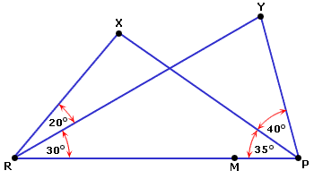
Monica is positioned with a third theodolite on the line between Rachel and Phoebe at a distance of 20m from Phoebe. Calculate the angle subtended by XY with Monica, i.e. ∠ XMY (to the nearest tenth of a degree).
  - Another possible follow-up question:
A large pond obstructs the survey line AB. Calculate the missing length PQ.
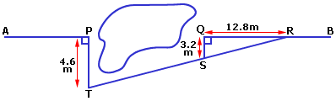

Item 10. Vertical sextant angles
Find the area of the block of land shown as Lot 23 (in square metres and in hectares).
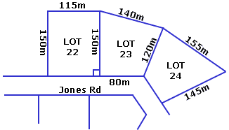
(Hint: Divide the area so as to obtain a right-angled triangle.)
© The State of Queensland (Department of Education and the Arts) 2002.

